Write ACL for Institution Details
Project Development Phase | 6 of 7
Project | Script-Controlled ACL - Restrict Record Access Based on Field Value
Date / Team ID | 1 October 2026 | Team ID: [enter team ID]

Purpose
Add a write ACL so the EEE test user can update EEE records while records in other branches remain protected.

Write ACL configuration
Setting | Value
Type / Operation | Record / write
Name | Institution Details [u_institution_details] / --None--
Decision type / Active | Allow If / selected
Admin overrides | Selected
Requires role | bb3 or u_institution_details_user; reconcile first.
Advanced script | Target condition Branch=EEE; not shown in the dedicated Write screenshot.

Write script
answer = current.getValue('u_branch') == 'EEE';

- Create a record ACL with Operation set to write and Name set to the Institution Details table. The dedicated Write screenshot requires u_institution_details_user, while another ACL screenshot shows bb3; reconcile the active role before testing.
- For the target configuration, select Allow If, Active, Admin overrides, and Advanced, then use the agreed Write role. The dedicated Write screenshot requires u_institution_details_user; the generic ACL conditions screenshot shows bb3.
- Paste the proposed Branch predicate and save. The supplied Write screenshots do not show an Advanced Branch script.
- Sign in as EEE User. Confirm an EEE sample record is editable and an ECE or CSE record is read-only or unavailable.
- Repeat as an administrator to confirm the Admin overrides behavior.
Protect the policy field Because Branch controls access, do not let an ordinary user freely change it to gain access or lock out other users. For a stronger design, add a field-level write ACL or server-side validation that prevents unauthorized Branch changes.

Acceptance checks
Test | Expected result | Actual / status
EEE User with resolved Write role updates an EEE record | Allowed. | To test
EEE User with resolved Write role updates an ECE or CSE record | Denied. | To test
User without the resolved Write role updates an EEE record | Denied. | To test
Administrator updates a non-EEE record | Allowed with Admin overrides. | To test

References
Project walkthrough: YouTube demonstration
ServiceNow documentation: Configure an ACL | ACL types | Explore ACLs

Screenshot evidence and implementation alignment
Evidence finding: The two supplied Write-related captures disagree on the required role: the dedicated Write form uses u_institution_details_user, while the generic ACL conditions image shows bb3. The dedicated form does not show an Advanced Branch script. Resolve the role and add/test the field check before treating Write as complete.
Dedicated Write ACL form requires u_institution_details_user; this differs from bb3 in the other ACL screenshot.
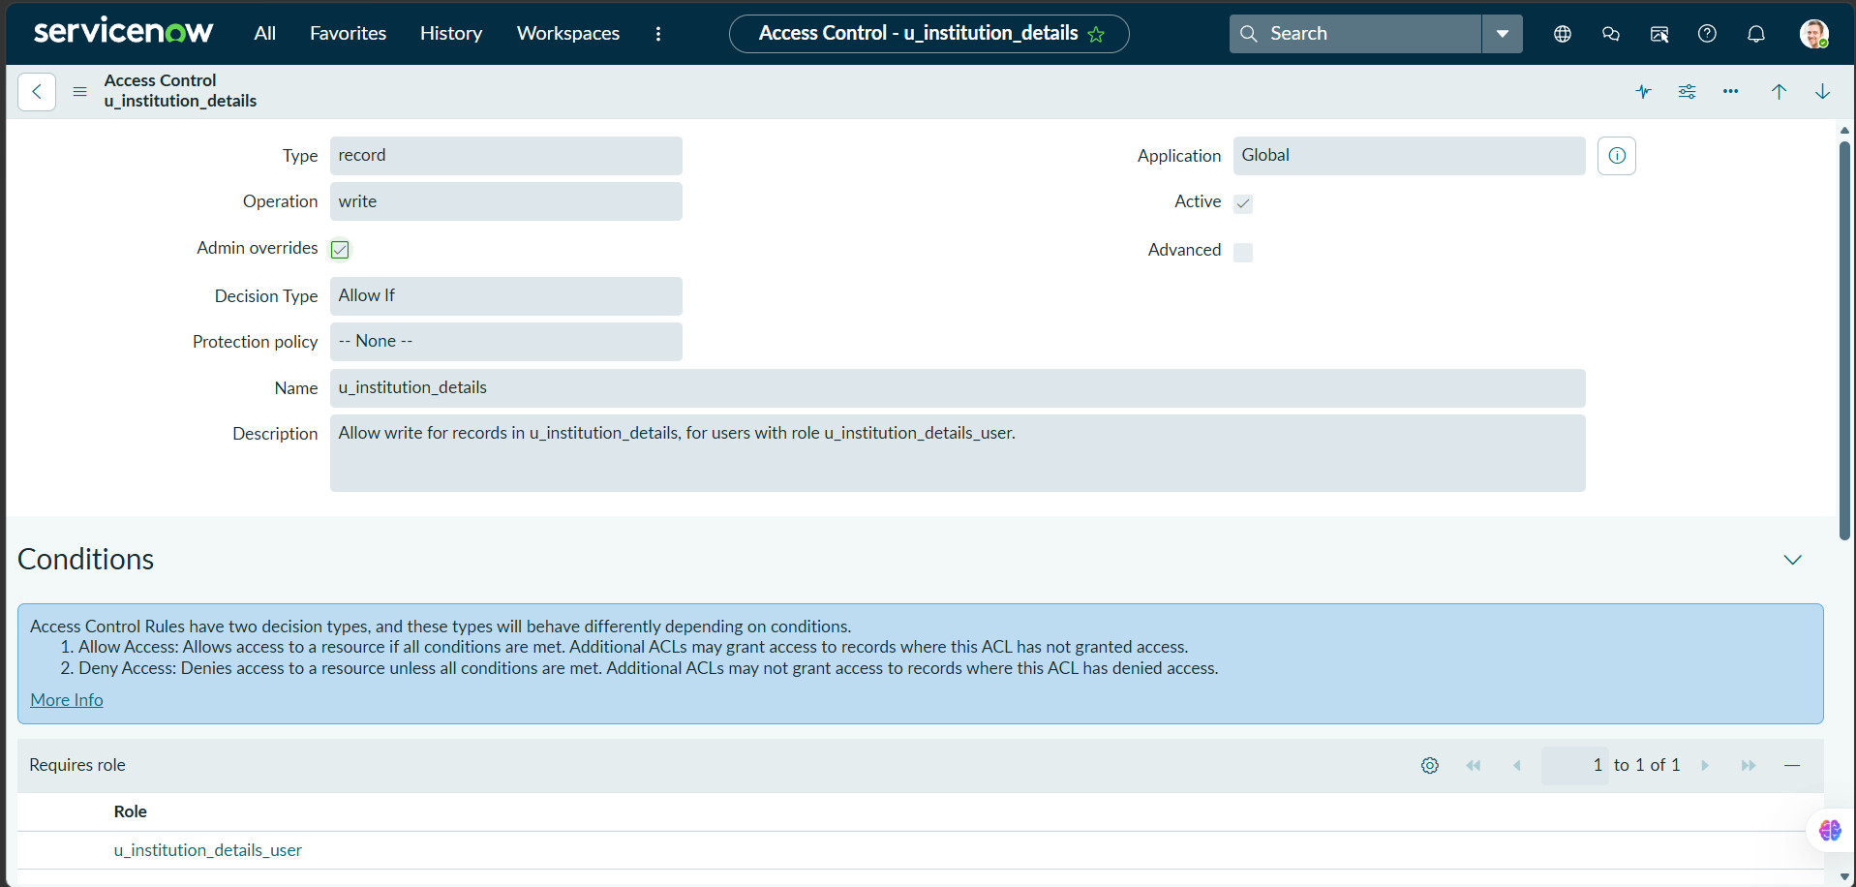

ACL conditions screenshot shows bb3. Reconcile this with the dedicated Write ACL form before claiming the role mapping is consistent.
